  - An Afternoon of Music and Poetry

Belmont Parish Hall Presents

Songs & Poems of the North
Join us on Thursday, 4th June for a special cultural event celebrating the music and poetry of Scotland, Ireland, and the North of England.
Time: 2:30pm – 4pm (Doors open at 2pm)
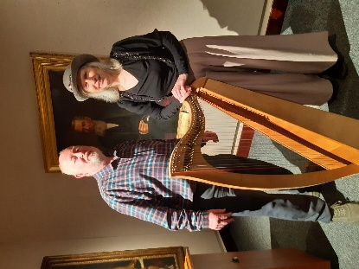

Featured Artists

Pauline Vallance
Pauline Vallance is a singer-songwriter and clarsach (Celtic harp) player from Ayrshire. With a warm and engaging stage presence, Pauline performs traditional songs from Scotland and Ireland, captivating audiences with her heartfelt renditions. Pauline has presented solo shows at the Edinburgh Fringe for many years and has received praise for her performances. Her latest album, The World's a Gift, was recognised as a 'Must Listen' by Folk London and nominated for Scottish Album of the Year.

Clive Wright
Clive Wright is a prize-winning poet born in Northern Ireland. He formerly served as Poet of Stirling (Makar), contributing to the local literary community, and has recently relocated to County Durham. Clive's most recent poetry collection, Thoughts in a Green Shade, was published in 2024. At this event, he will share poems from his new collection, as well as works reflecting his experiences in Scotland and Durham.

Admission
£10 (cash on the door).

